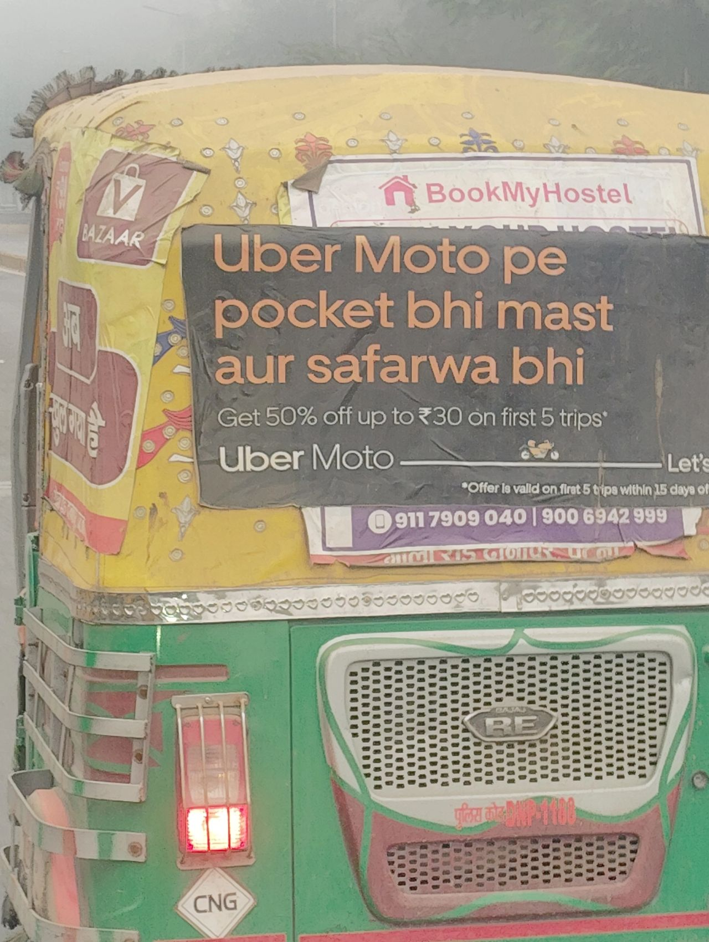
"Bolna kya chahte ho bhai?"

Back in my hometown after a year long study spanning multiple Indian cities at different stages of growth.

And If 2025 has taught me one thing, it is that while everyone talks about "context", making the right use of context is a whole different ball game.

Team at 1001 Stories often discusses the importance of language being contextually informed when crafting communications, brands, and interventions.

What we also understand, is that people often mistake that as mimicking the linguistic context of the user.

That is simply not true- infact, it can often break things.

Banks trying to communicate with younger audiences using genZ lingo often backfires, making them feel too close to be seen as authority figures.

Services and aggregators make the same mistake - ending up feeling like a friend you would hang out with privately but not take services from.

Took me a minute trying to understand what the copy here from uber was even trying to tell me.

It trades clarity for "resonance" - fun to attempt as a creative, but bad strategy.

1. Bike services are primarily functional, not luxury / experiential.

2. The base expectation is cost effectiveness, and safety.

3. The meaning of "mast" ride is often "fun"- not safe here. You cannot make a bike ride "fun" - because of how traffic and infra interact here, you can only make it safe.

4. "Safarwa" as a word doesn't exist, for heaven's sake, adding "wa" to everything doesn't make it Bihari.

Worse, when the brand is not regional, very quickly interpreted as mockery.

One has to already be "One of our own" to operate in that zone.

5. Services have to come as leading, authority symbols in this belt - relevant not just for the individual, but the collective. That's where a sense of safety comes from.

Rapido's comms. are targetting the right things. Aiming safety through collective approval and downloads through pricing promises. Without trading clarity.

Context is not just "A" consideration to make, it is everything within which the problem you're trying to solve exists - and matching the right right elements, the right way.

The numbers show for it when done right.

